
2026-2027 FAFSA Completion Guide
StudentAid.gov
1
Gathering Documents

- Email address and mobile phone number
- StudentAid.gov account for both the student and the dependent student’s parent/stepparents (in some cases, each parent may need their own StudentAid.gov account)
- Your Social Security number
- Your alien registration number or USCIS number (if you are not a U.S. citizen)
- Your 2024 federal income tax returns and W-2s (only if required to enter manually)
- Bank statements and records of investments (if applicable)
- Parent’s email address(es)

2
Federal Student Aid Process

- Create a StudentAid.gov account (username and password). See p. 2 for instructions

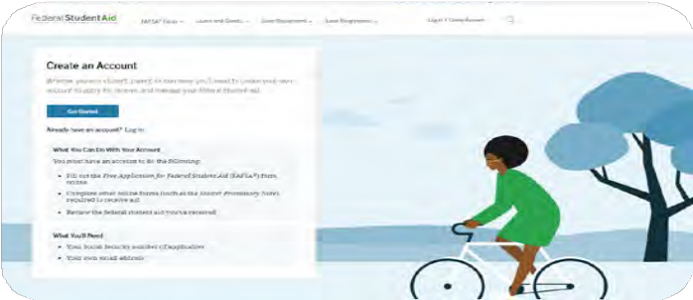

3

Dependency Status

- Visit StudentAid.gov where you and your contributor(s) can complete the FAFSA for the year you are entering college.
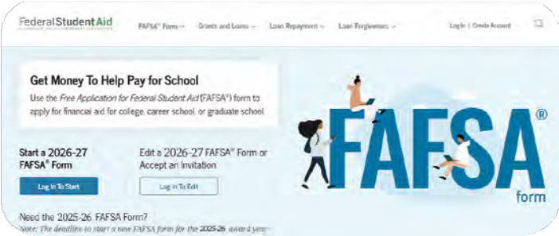

Review and Submit
4
Visit StudentAid.gov – you and your contributor(s) can complete the FAFSA for the year you are entering college.

Already have a Student Aid Account and forgot your login?
Scan here to retrieve it!


StudentAid.gov Account Process
1 | 2 | 3 | 4 | 5
Visit StudentAid.gov and click on Create Account. | Create a memorable username and password.  **Be sure to keep track of your login information! You will use it in the future! | Enter your contact info and select if you would like to use your mobile number to login (this option allows for two-step verification). | Select your communication and language preferences.  Set up your challenge questions. | Confirm and verify your contact information using the secure codes sent to each contact method you chose to verify.

Dependency Status*

- Were you born before January 1, 2003?
- As of today, are you married?
- Do you or will you have children or other dependents who receive more than half of their support from you between July 1, 2026 and June 30, 2027?
- Are you active-duty military or a veteran of the U.S. Armed Forces?
- At any time since you turned age 13, were you either an orphan (no living biological or adoptive parent), a ward of the court, or in foster care? Your school may request documentation to verify your status.
- Are you or were you in a legal guardianship with someone other than your parent or stepparent, as determined by a court in your state of residence?
- At any time on or after July 1, 2025, were you unaccompanied and either homeless or at risk of being homeless?
*If you don’t answer “yes” to any of the questions above, you’re still considered a dependent student for purposes of applying for federal student aid even if you don’t live with your parents, are not claimed by your parents on their tax forms or are paying for your own bills and educational expenses.

- Contributor Determination
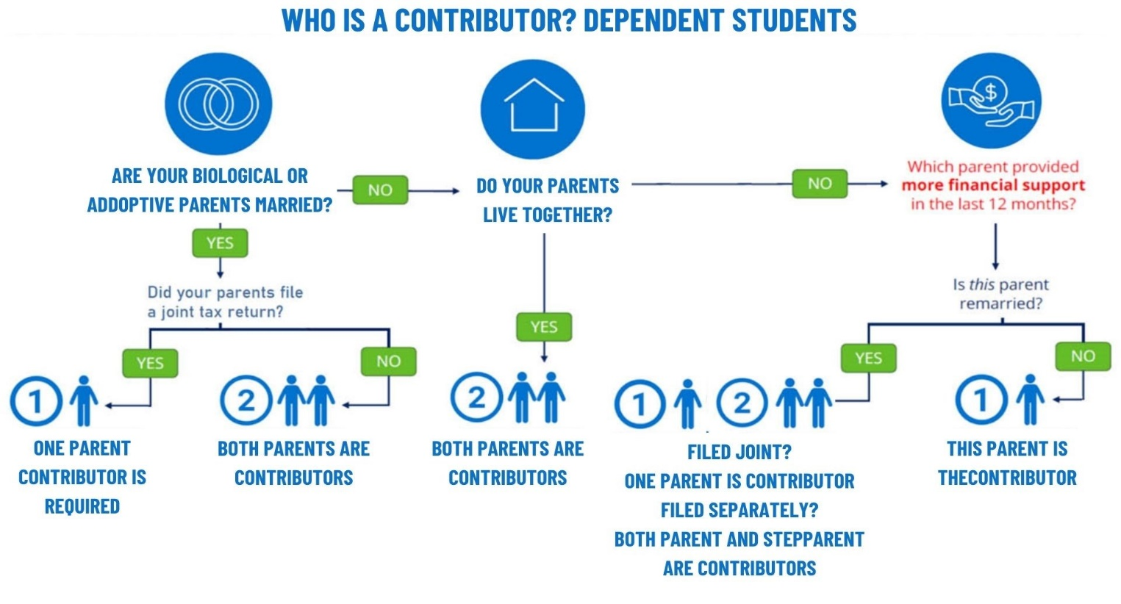
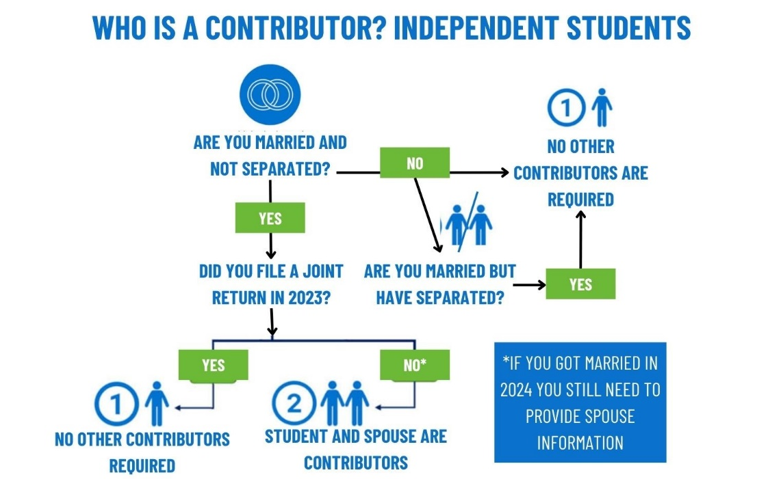

- Contributor Invitation Instructions

1. Login to your StudentAid.gov account | 2. Start a New FAFSA Form or Continue an Existing One | 3. Enter Contributor’s  Information
Visit StudentAid.gov and log in with your username and password. If you don't have an account, click on Get Started and follow the prompts to set one up. | Navigate to the Contributors  Section. Once logged in, either  start a new FAFSA form or open  an existing one. Look for the  “Contributors” tab in the FAFSA  form. This section allows you  to add a parent or spouse as a  contributor to your application. | Add the email address, then click "Send Invitation."
4. Contributor Receives  Invitation | 5. Contributor* Completes  Their Section | 6. Final Review and  Submission
The contributor will receive an email with a unique code to your FAFSA. They will need to create their own StudentAid.gov account (if they don't already have one) to log in and complete their section. | Once logged in, the contributor will fill in their financial information and sign the FAFSA.  *If you have more than one contributor (see chart on page 2):  - Contributor #1 will have to invite contributor #2 through their section.  - Contributor #2 will be required to complete steps 3 through 5 before you can move on to Step 6. | After your contributor(s) completes their section(s), log back into your FAFSA account. Review details and make sure everything is correct. Your FAFSA is now complete!

- Helpful Hints

Assets
- Asset net worth means current value of the assets minus what is owed on those assets.
- Assets include: money in cash, savings, and checking accounts; businesses (over 100 employees); investment farms; other investments, such as real estate (other than the home in which you live); UGMA and UTMA accounts for which you are the owner; stocks, bonds, certificates of deposit, etc.
- Assets do not include: the home and farm where you live; UGMA and UTMA accounts for which you are the custodian but not the owner; value of life insurance; retirement plans (401[k] plans, pension funds, annuities, non-education IRAs, Keogh plans, etc.).

Communication
- Use a personal email (not school) that you check often for the StudentAid.gov account and the FAFSA. You will receive IMPORTANT information and directions via email.

Data Security
- Each email address and mobile phone number can be used with only one StudentAid.gov account. If you share an email address with someone else, then only one of you will be able to use that email address to create an account.
- Keep track of all usernames and passwords in a safe, secure place. You will need your www.StudentAid.gov account every year you complete a FAFSA, as well as log in to all Department of Education websites.
- Name and Social Security number need to match what is on your Social Security card and tax forms, if applicable.
- Each contributor will need to grant consent to use the Direct Data Exchange (DDX), even if they didn’t file taxes.
- After submitting, review the FAFSA Submission Summary for your FAFSA updates.

First Year college students
- The grade level for high school seniors and first-year students will be “first-year freshmen”, even if you have taken AP or dual credit courses.

Website navigation
- To get clarification and guidance for each data field, click on the question mark next to each data box to show HELP text.
- Make sure that you select the correct form. High school seniors graduating in 2026 will need to complete the 2026–2027 FAFSA.

- Glossary

Verification
Colleges are required to verify the information provided on some FAFSAs. Most people selected for verification
are picked at random. If you’re selected for verification, you’ll be contacted by the college. The college or, in
some cases, an agency with which the college has contracted will let you know what forms and information
you need to supply.
If you are chosen for verification - DON’T PANIC. YOU HAVE DONE NOTHING WRONG!
Don’t delay. It’s important to complete verification as soon as you’re notified so there are no delays with your financial aid.

Aid offer
Sometimes called an aid notification or award letter, an aid offer tells you what financial aid you can receive at a particular college or career school.

Special circumstances
If you believe you have special circumstances that were not accurately reflected on your FAFSA, contact the financial aid office at the college you plan to attend.

Dependency override
Authority given to financial aid administrators to change a student’s status from dependent to independent in cases involving unusual circumstances.
Federal Pell Grant
A Pell Grant is a federal grant that helps eligible students pay college costs. It’s a need-based
grant that doesn’t need to be paid back, except in certain circumstances.

Need Help? Contact the SUNY Adirondack Financial Aid Office:
Phone: 518.743.2223
Email: finaidoffice@sunyacc.edu

