# Student Banner 9

Banner is the college’s student information system. Here you can obtain your login information, register for courses, print class schedules, review and accept your financial aid, find the necessary access information for the campus wireless network and check your paystub if you are a student employee.

To log into Banner, you will go through the [MYSUNYADK student portal](https://www.mysunyadk.com/) (<https://www.mysunyadk.com/>) using your Network ID and password. Then select the Banner link from the menu at the top of the page.

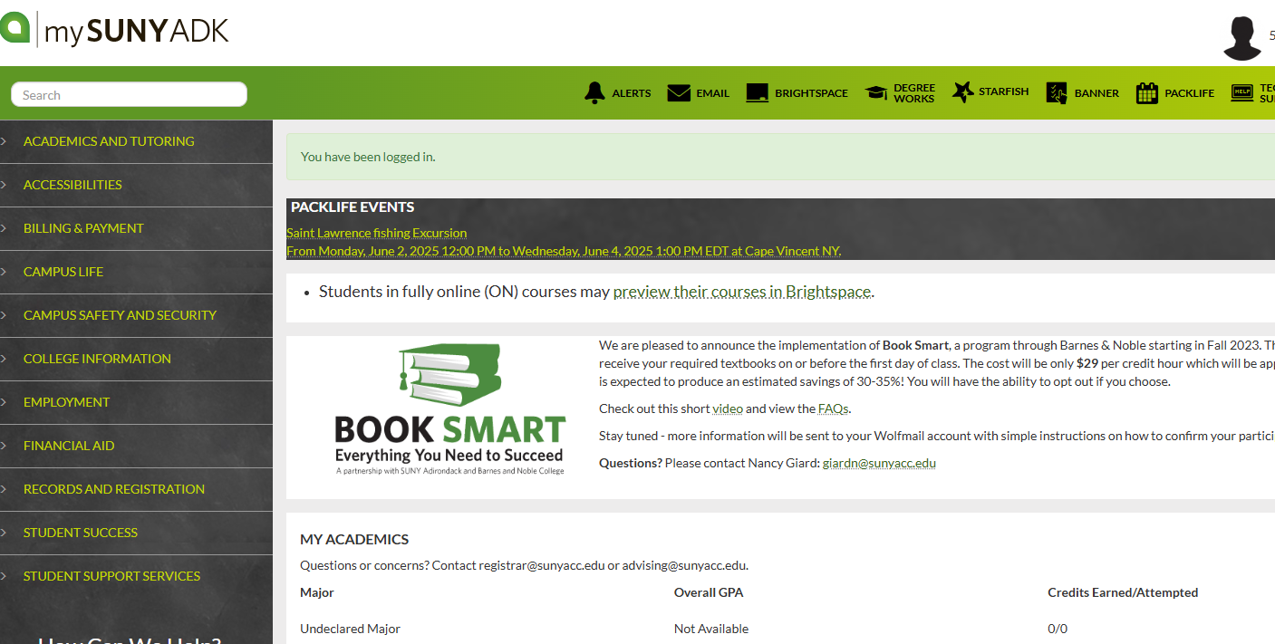

Additional information about your SUNY Adirondack accounts is available via the SUNY Adirondack technology page (<https://www.sunyacc.edu/technology>) of the website.

# Navigating the Financial Aid Section in Student Banner 9

The Financial Aid Section is organized into a series of tabs that guide you through the information and actions you may need to take. Choose the award year you want to view from the dropdown menu on the top right. Click through the tabs to review your information and complete any necessary steps. Pay attention to outstanding requirements, notifications and/or alerts, which will guide you to what is needed.

1. Accessing the Financial Aid Dashboard
2. Home
3. Award Offer
4. Financial Aid History
5. Resources
6. Notifications
7. Satisfactory Academic Progress (SAP)
8. College Financing Plan
9. Tips

## 1. Accessing the Financial Aid Dashboard

* After logging in, select “Financial Aid” from the [Student Services menu](https://banner.sunyacc.edu/StudentSelfService/ssb/studentCommonDashboard) (<https://banner.sunyacc.edu/StudentSelfService/ssb/studentCommonDashboard>).

Screenshot of Student Services menu on Banner dashboard


## 2. Home

* Select the correct award year from the dropdown menu.
* Review any unsatisfied or satisfied requirements.
* Complete required actions as prompted. Contact [Financial Aid](mailto:financialaidoffice@sunyacc.edu) (finaidoffice@sunyacc.edu) with questions.

Screenshot of the  Home tab in Financial Aid section


## 3. Award Offer

* View your Expected Enrollment Status, Student Aid Index (SAI), Cost of Attendance (COA), Award Offer, and Net Cost.
* Accept, decline, or accept a partial amount of your federal loans:
  + To accept all, click “Accept Full Amount of All Awards.”
  + To accept/decline by fund, use the appropriate buttons.
  + To accept a partial amount, enter the amount in the provided field.
* Remember: Awards are typically split evenly between Fall and Spring semesters unless enrolled for only one semester.

Screenshot of the Offer tab screen, showing Expected Enrollment Status, Housing Status, and Student Aid Index.


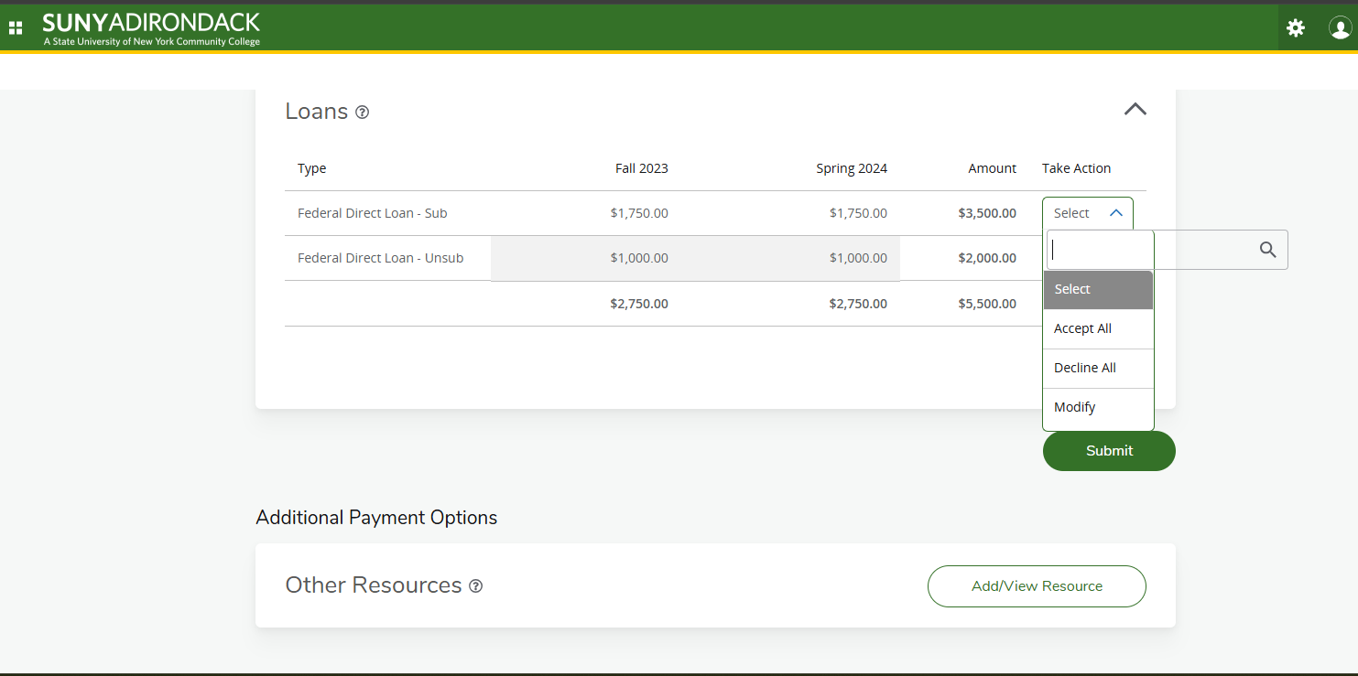

## 4. Financial Aid History

* Select an award year or “all years” to see your financial aid history, including loans, grants, and other awards received previously.

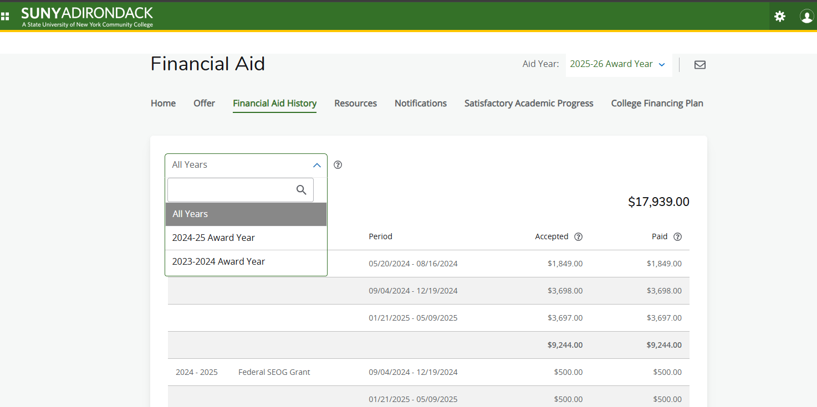

## 5. Resources

* Review the terms and conditions for your financial aid.

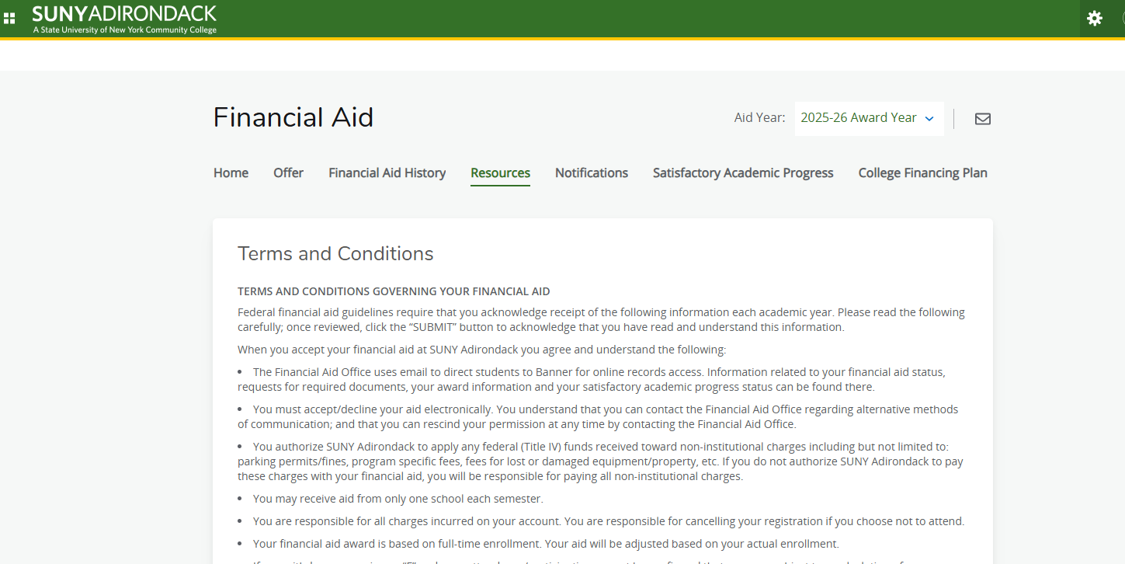

## 6. Notifications

* View important messages from the financial aid office, such as requests for additional information or updates about your financial aid.

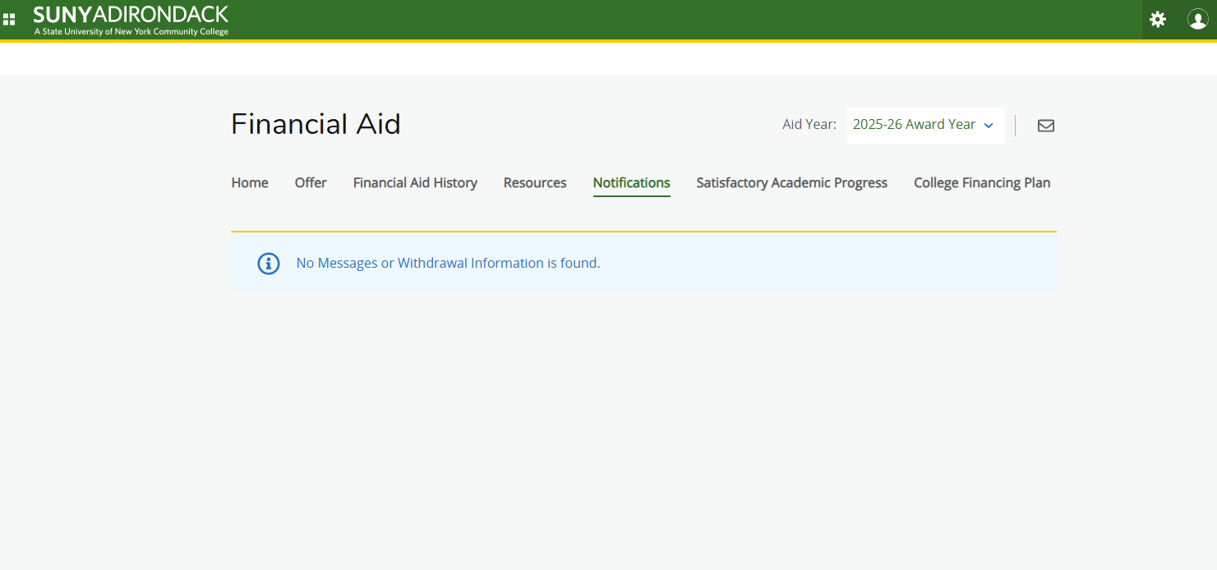

## 7. Satisfactory Academic Progress (SAP)

* Check your SAP status to ensure you remain eligible for financial aid.
* Review detailed SAP policy information if needed.
* Submit a [financial aid appeal form](https://sunyacc.edu/admissions-aid/financial-aid-and-scholarships/financial-aid-forms) (<https://sunyacc.edu/admissions-aid/financial-aid-and-scholarships/financial-aid-forms>) if your financial aid eligibility was lost.

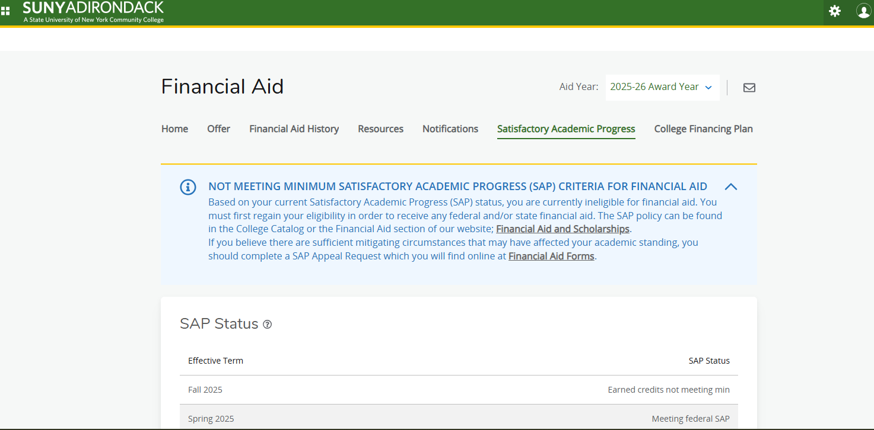

## 8. College Financing Plan

* Review a summary of your financial aid offers compared to the estimated cost of attendance.
* Note: **This is not your actual bill.** For actual costs, check your student account or billing section.
* Print a copy if needed.

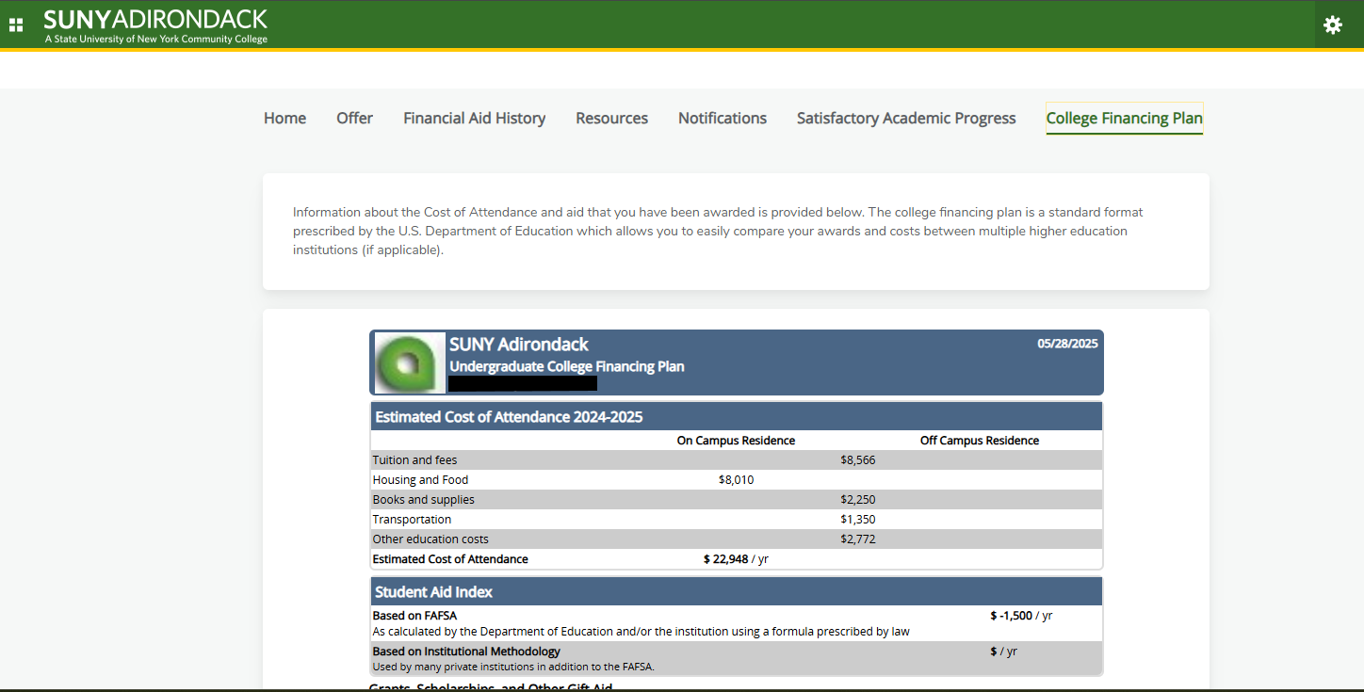

## 9. Tips

If you have any questions about navigating Banner, please contact:

* Financial Aid: finaidoffice@sunyacc.edu for questions related to financial aid
* Student Success: advising@sunyacc.edu for questions related to registration or schedule
* Help Desk: help@sunyacc.edu for questions/issues related to account access
* Student Accounts: [studentaccounts@sunyacc.edu](mailto:studentaccounts@sunyacc.edu) if you have questions about your bill or a hold on your account.

**Always check for unsatisfied requirements - they can delay your aid.**