**What is RWG?** RWG is a software that makes the web, documents and files more accessible - any time, any place, and on any platform or device. From reading on-screen text aloud to researching and checking written work, Read & Write Gold makes lots of everyday tasks easier.

**How do I download it?**

1. Head to <https://www.texthelp.com/confirmation/readandwrite-product-trial-confirmation/>
2. Next complete the Start your Free Trial Section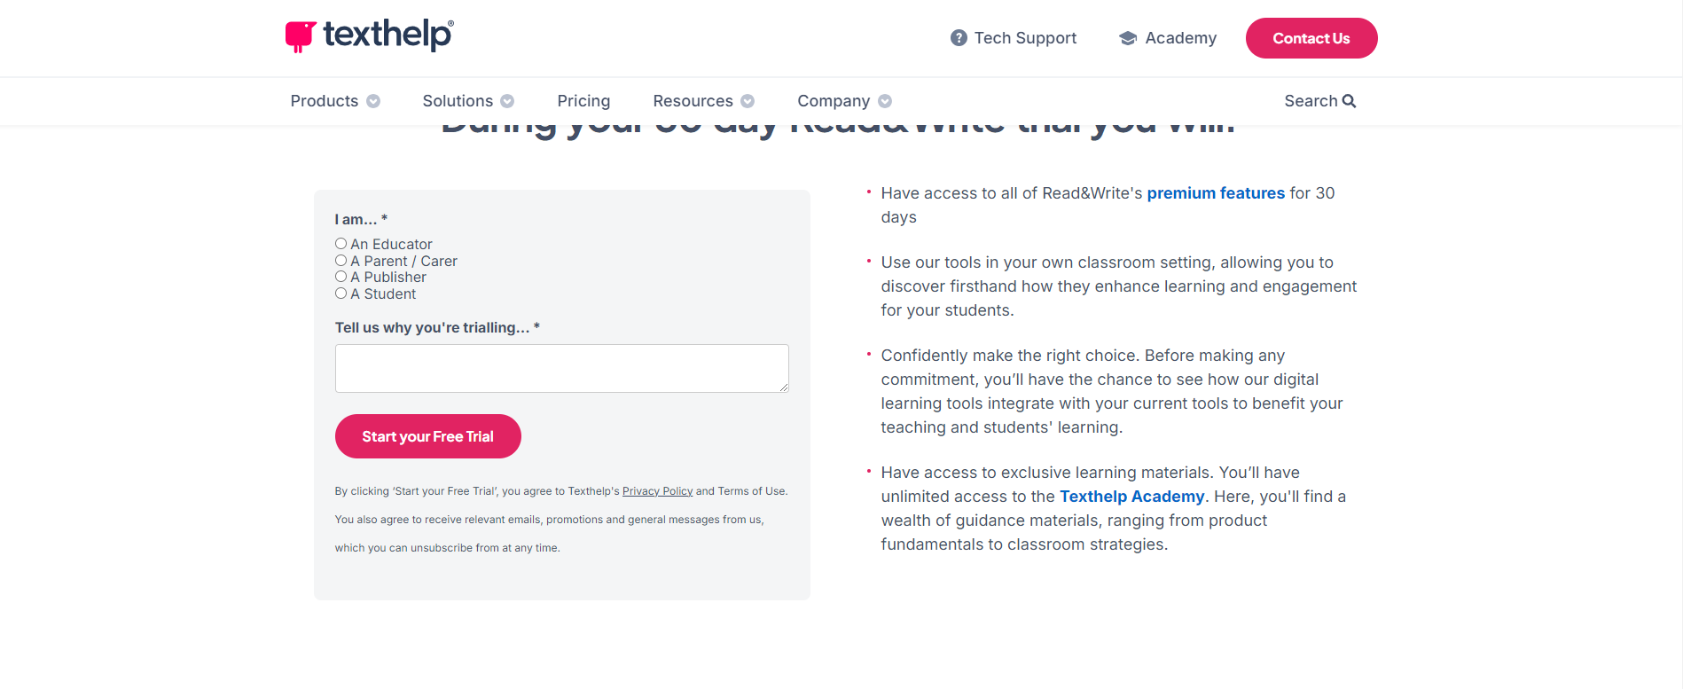
3. Choose the correct download for your platform (Chrome Users will also need to download an extension from the Google Play Store)

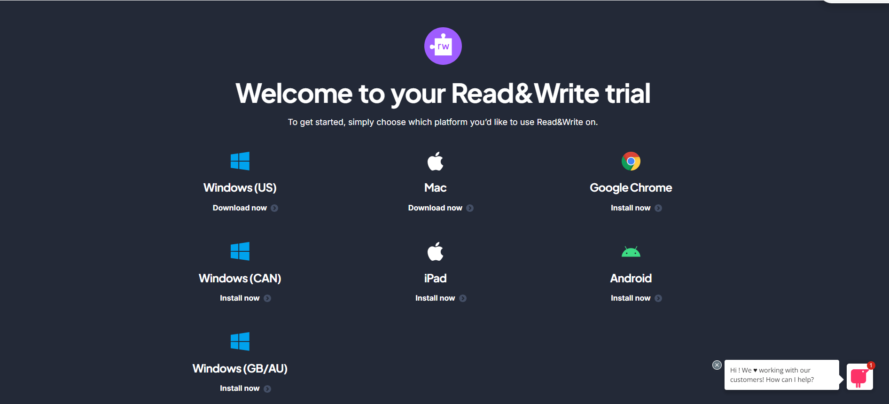

1. Once Downloaded and the toolbar appears at the top of your screen, Sign Into your SUNY Adirondack Wolfmail Account to get full access



**How do I use RWG?** Here is a list of helpful and information short videos for users

[Videos for Windows Users](https://www.youtube.com/playlist?list=PLvSZbmGbKpCQEi1OB-nu-wA5KexHppO9C)

[Videos for Chrome Users](https://www.youtube.com/playlist?list=PLvSZbmGbKpCTkk3S93CXtQWNf50f_Ow3D)

[Videos for Mac Users](https://www.youtube.com/playlist?list=PLvSZbmGbKpCSms6EDxSVm7oaysekYLIPZ)