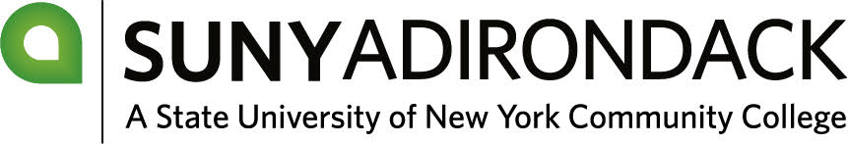
2026-27 Verification Worksheet
Your application for federal student aid, the Free Application for Federal Student Aid (FAFSA), has been selected by the U.S. Department of Education for the verification process (34 CFR, Part 668). For this process SUNY Adirondack is required to verify that the information on this worksheet matches the FAFSA you submitted. If there are differences between your application and this information then corrections may be made. You will receive acknowledgment of these changes from Federal Student Aid.
Section A: Student Information
______________________________________________
Last Name First Name MI SSN
______________________________________________
Address City State Zip Code
______________________________________________
Date of Birth Email Address Phone Number

Section B: Household Information

 Dependent Students
List the people in your household, including:
- Yourself
- Your parent(s), including stepparent (if applicable)
- Any children or individuals for whom your parent(s) currently provide and will continue to provide more than half of the financial support from July 1, 2026 through June 30, 2027.

 Independent Students
List the people in your household, including:
- Yourself
- Your spouse (if married)
- Your children or other individuals for whom you currently provide and will continue to provide more than half of the financial support from July 1, 2026 through June 30, 2027.

Full Name | Age | Relationship | Current College (2026-26)
Example: Eddy Rondack | 18 | student | SUNY Adirondack

**You may attach a list of additional household members, if needed**
Section C: Income & Federal Tax Information
Tax Status Requirements: Student and Spouse Contributor (if married)
 You/your spouse consented to provide 2024 income information through the IRS Direct Data Exchange System (DDX).
 You have attached either 1) a signed copy of your 2024 ISR Income Tax Return (1040); or 2) a copy of your 2024 IRS Tax Return Transcript for you and/or your spouse (if applicable) to this worksheet.
 You and/or your spouse had no taxable income, will not file and were not required to file a 2024 Income Tax Return. Verification of non-filing document from the IRS for 2024 and a copy of wage/earning statements from the IRS for 2024 for you/your spouse are attached. These tax documents can be obtained at www.irs.gov.
Tax Status Requirements: Parent(s) and/or Stepparent Contributors (if applicable)
 All required contributors consented to provide 2024 income information through the IRS Direct Data Exchange System (DDX).
 All required contributors attached either 1) a signed copy of their 2024 ISR Income Tax Return (1040); or 2) a copy of their 2024 IRS Tax Return Transcript to this worksheet.
 Your contributor(s) had no taxable income, will not file and were not required to file a 2024 Income Tax Return. Verification of non-filing document from the IRS for 2024 and a copy of wage/earning statements from the IRS for 2024 for you/your spouse are attached. These tax documents can be obtained at www.irs.gov.

Section D: Signature Certification
By signing this worksheet, I/we certify that all the information reported on this form is complete and correct. Pursuant to federal law, if you purposely give false information on this worksheet you may be fined, sentenced to jail, or both.
__________________________________________ ________________
Student Signature Date

__________________________________________ ________________
Parent Signature (Dependent Students only) Date

Please return your completed and signed form to the Financial Aid Office:

SUNY Adirondack
ATTN: Financial Aid Office
640 Bay Road
Queensbury, NY 12804

Or:
Email: finaidoffice@sunyacc.edu
Fax: 518.743.2414

